# Project Milestone 4 – Technical Brief Draft

To: Avery D. Lion, President, Natural Catalysts Inc.

From: ENRG 132 006-10 Creigh Dircksen, Joe Pahoresky, Winston Lin, Taylor Duchinski

RE: Technical Brief of Final Results

Date: April 24, 2022

## Introduction

NaturalCatalyst is presenting us with data about ten different enzymes and expecting an analysis of each one including information about the initial slope, maximum value and median value. This analysis must include easy to read infographics and clear data. Finally, we must calculate error based of real values for the information requested above.

The algorithm our team developed uses a main function with four subfunctions. Each subfunction has a specific job, one for V0i, Vmax, Km, PGOX50.

For calculating V0i, we had to choose between using calculus to generate a derivative or using the first 80 values and found the average rise over run. We chose the latter because we believed that it would still yield sufficient results while being much less time-consuming. A second decision we made to improve the algorithm is deciding how to calculate Vmax. We chose between simply checking what the last value of the plot was and using that for Vmax or using a formula that included plotting the inverse of S and V and using the inverse of the y intercept for Vmax. We decided on the latter option because it was a more defined method of calculating that value. One last decision we made came towards the beginning of the project when we were deciding what to do with each of the duplicate tests. Our ideas were to use only the original data and disregard the duplicate, the option we went with was to average the data with its duplicate before anything was done to increase the accuracy.

Parameter Identification Procedure

Our algorithm sorts through the algorithms and each starting concentration (S) to be able to pass matrixes that are workable to find the needed information. Once sorting through the data, we calculated the initial velocity of the reaction by taking the average of the first 80 seconds of concentrations for each enzyme and each starting S value and dividing that number by the average time that takes place over the 80 seconds. Once we get the initial velocity of the given concentration, we average that number with the duplicate data given by the second test for each enzyme. Once we calculate all the initial velocity for each starting concentration, we use a process called the Lineweaver-Burk plot (Libretexts). This process entails dividing one by each of them to find the inverse. We then find the inverse of the initial concentration as well as the inverse of the initial velocity, we graph that information. This is the linearized graph in which we find the slope and y intercept of using the Least Square Regression equations (Kenton, W.). When we have the y-intercept, we take the inverse of that to find the velocity maximum value. This is the point in the reaction when the concentration of the reactant decreases by a negligible amount (Lineweaver Burk Plots...). We then divide the slope by the y-intercept to find the Km value which is a coefficient used in the equation to find an initial velocity given an initial concentration. After finding these coefficients of the maximum velocity and the Km value, we graph the initial velocities compared to the initial velocities calculated by the model.

Results

Based on our data, you can see how the initial velocities calculated by the model correspond with the actual initial velocity. Looking at the figure, it is easy to see that figure 1 has a calculated initial velocity that corresponds most directly with the actual initial velocity. Figures 2 and 3 show that Enzymes B and C are the most inconsistent in representing the data and in how the velocity of the reaction is not consistent with different starting concentrations. Figures 4 and 5 representing Enzymes D and E show how those two enzymes have the fastest reaction rate based off the starting concentrations with figure 5 consisting of the fastest initial velocities for out of all the enzymes. Table 1 shows the maximum velocity and the Km values of each Enzyme. Looking at table 1, it is visible that the reason for this is because of the high maximum velocity of Enzyme E with a lower Km relative to the other Enzymes.

## Interpretation

The error within each enzyme could be linked to the fact that each enzyme has different properties than the reference enzyme used to get sample numbers to help calculate V0i. From our data, our mathematical models for identifying the parameters have little error in it itself. The problem is when we calculated V0i, we used an algorithm with reference values given to find which parameters were the most accurate, and how many values were used to calculate the slope for V0i for those accurate parameters. However, the same number of values used does not always work for every other enzyme.

There were also potential errors in calculating Vmax and Km, as we used the Lineweaver Burk model to find both of those parameters. However, they are based on the reciprocal of the original S and V0i data. While the model itself may be accurate, inconsistencies (noise) within experimental data is amplified with this model.

A natural catalyst is a way to facilitate the reaction which can speed up the reaction rate or cause the reaction to occur in the first place. Their enzyme catalysts help facilitate the reactions well giving for nice general reaction rates on a macro scale, but zooming in on the data, the catalyst is not completely consistent at cause the reaction to be at the same rate all the time. Looking at each of the enzymes, it seems that Enzyme E has the best reaction initial reaction velocity based on the coefficients we calculated from the data.

## References

Libretexts. (2020, September 1). *10.2: The equations of enzyme kinetics*. Chemistry LibreTexts.

Retrieved April 5, 2022, from https://chem.libretexts.org/Bookshelves/Physi%20cal_and_

Theoretical_Chemistry_Textbook_Maps/Map%3A_Physical_Chemistry_for_the_Biosciences_(C

ang)/10%3A_Enzyme_Kinetics/10.2%3A_The_Equations_of_Enzyme_Kinetics

*Lineweaver Burk plots – MCAT biochemistry*. MedSchoolCoach. (2022, March 23). Retrieved April

5,2022, from https://www.medschoolcoach.com/lineweaver-burk-plots-mcat-biochemistry/.

Kenton, W. (2022, March 29). *Understanding the least squares method*. Investopedia. Retrieved April 15, 2022, from https://www.investopedia.com/terms/l/least-squares-method.asp

## Appendix: Figures and Tables

Table 1.

|  |  |  |  |  |  |
| --- | --- | --- | --- | --- | --- |
| **Enzymes** | NextGen-A | NextGen-B | NextGen-C | NextGen-D | NextGen-E |
| **Vmax (μM/s)** | 0.983 | 0.910 | 1.324 | 1.532 | 1.608 |
| **Km (μM)** | 164.78 | 364.08 | 218.79 | 292.83 | 178.60 |

Figure 1 Figure 2

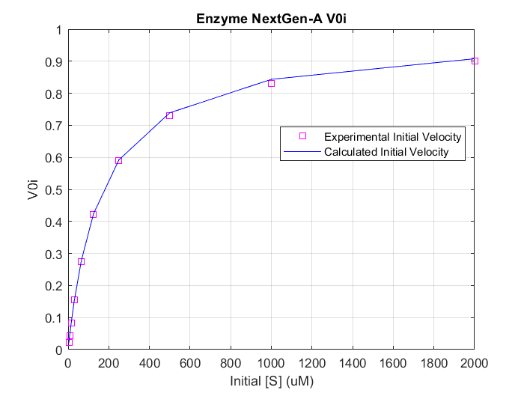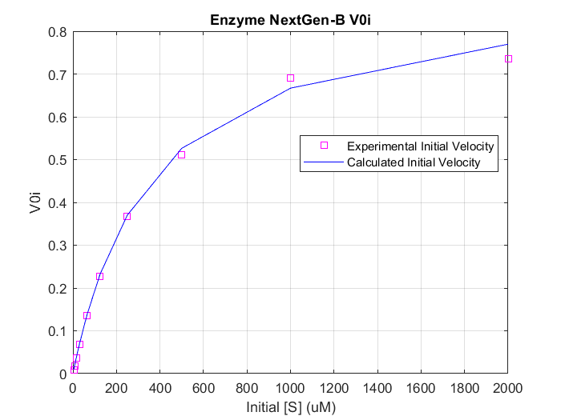

Figure 3 Figure 4

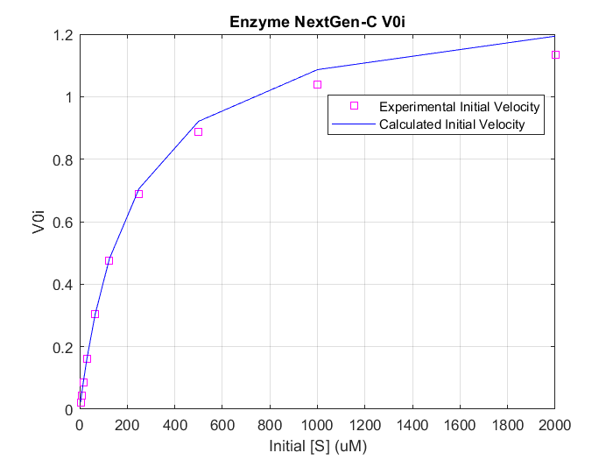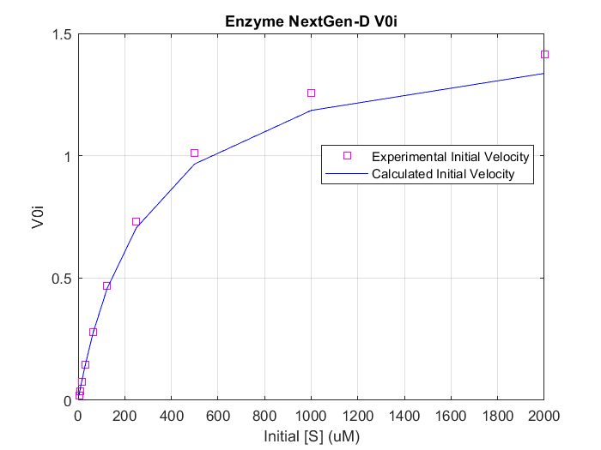

Figure 5

